

CAVENDISH UNIVERSITY - ZAMBIA

ASSIGNMENT BRIEF AND FEEDBACK FORM

STUDENT No ……………………..………… 103-637

LECTURE ……………………………………........MR. MOONGA

MODULE …………………………………E-COMMERCE

MODULE CODE ………………………………….COM224

ASSIGNMENT No ……………………………….. Two

DUE DATE…………………………………………10th November, 2023

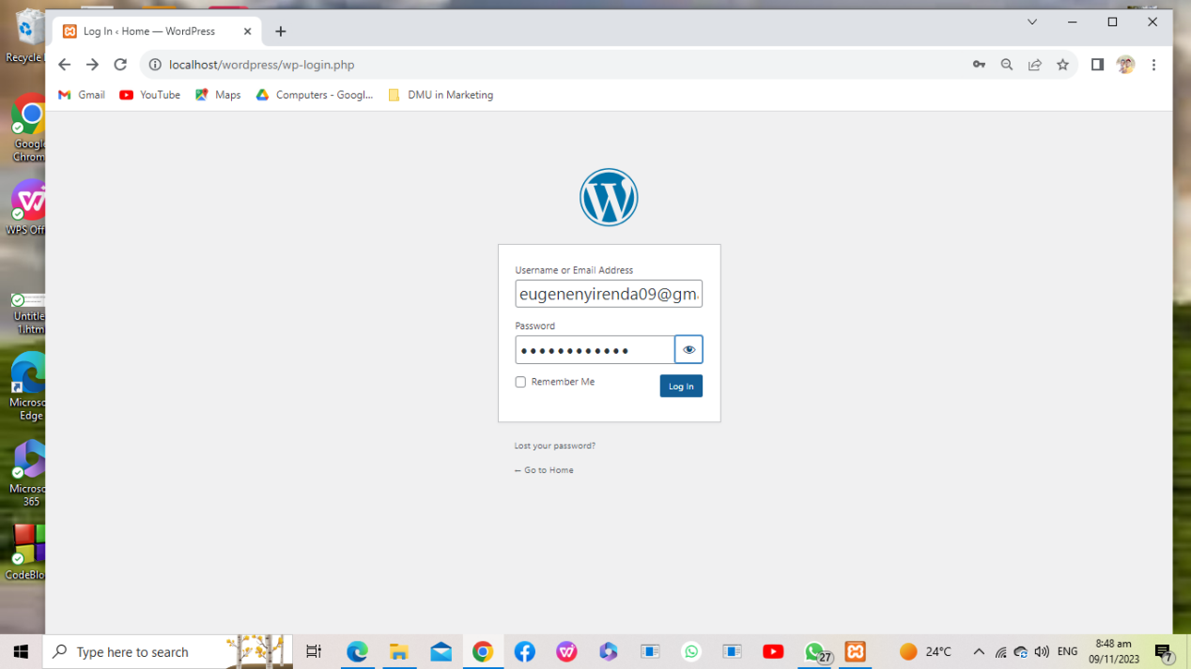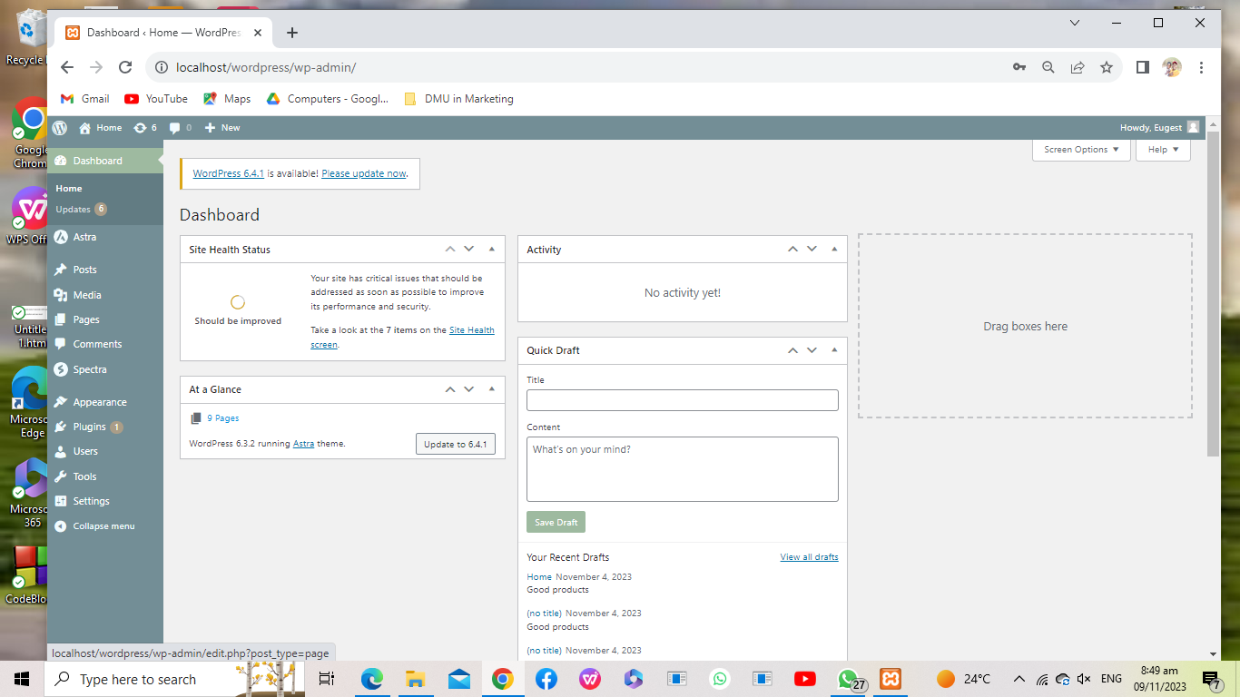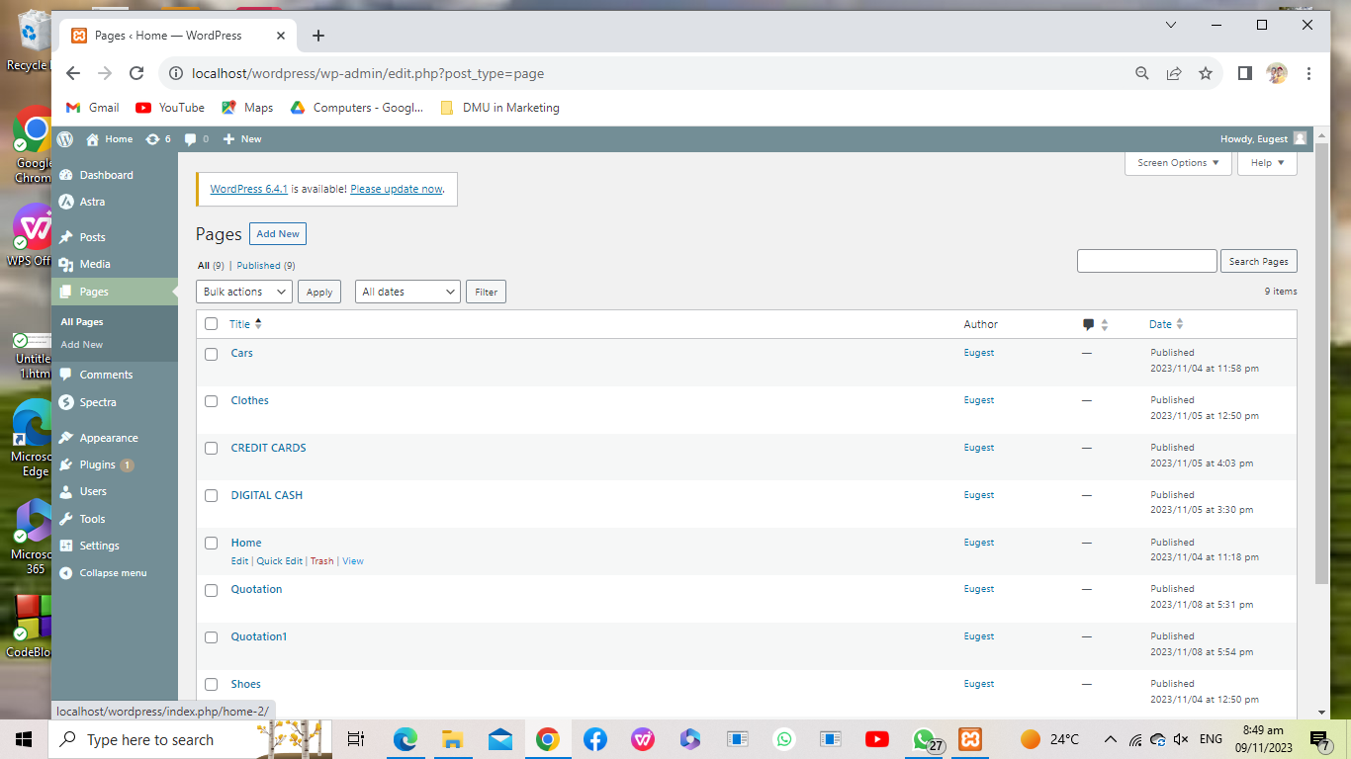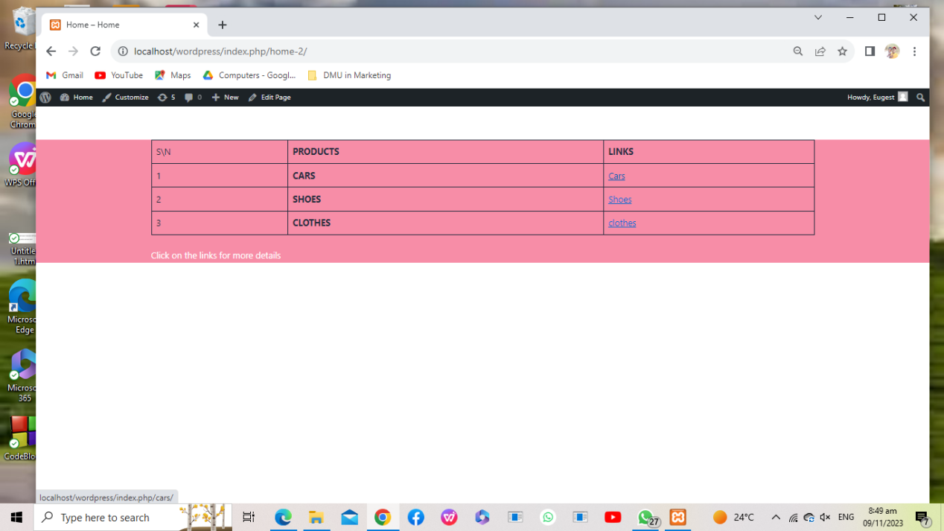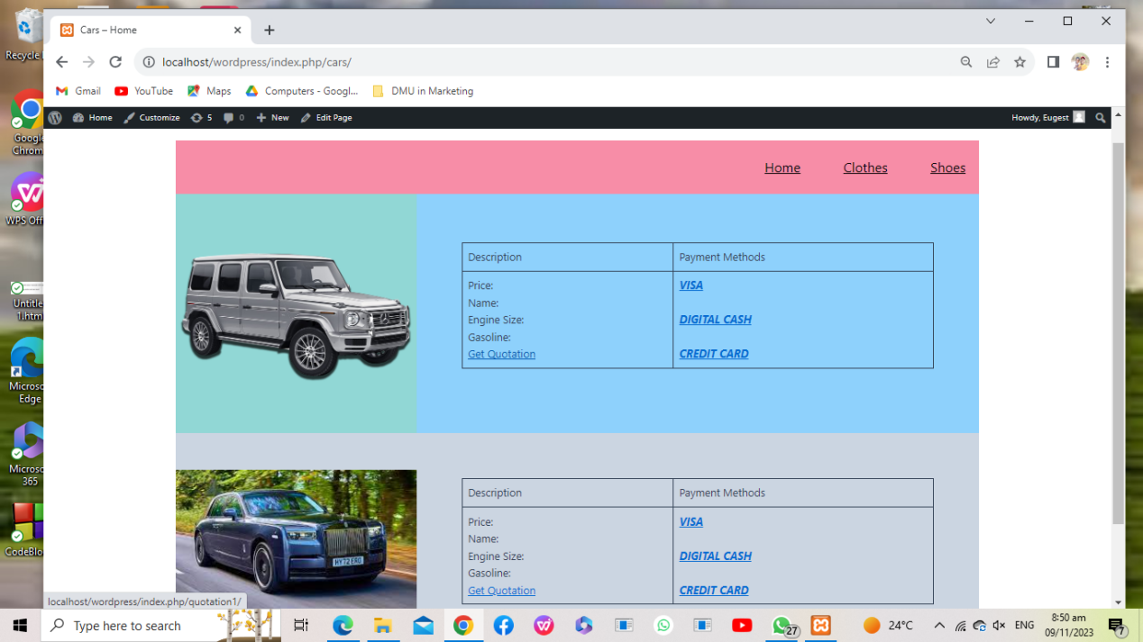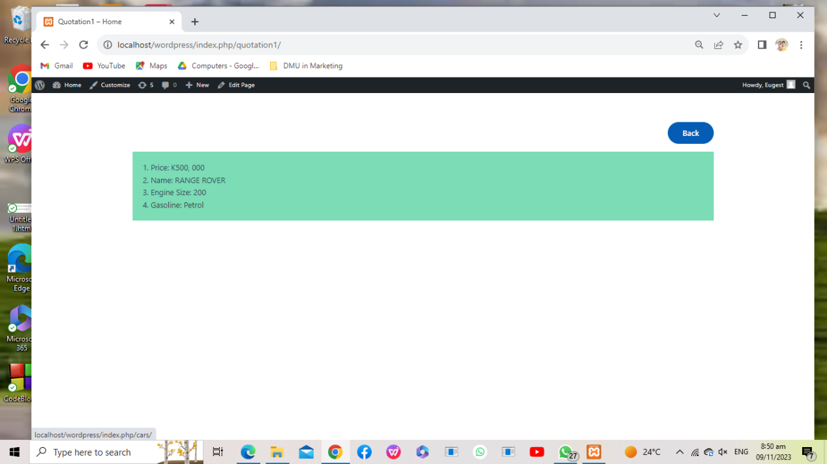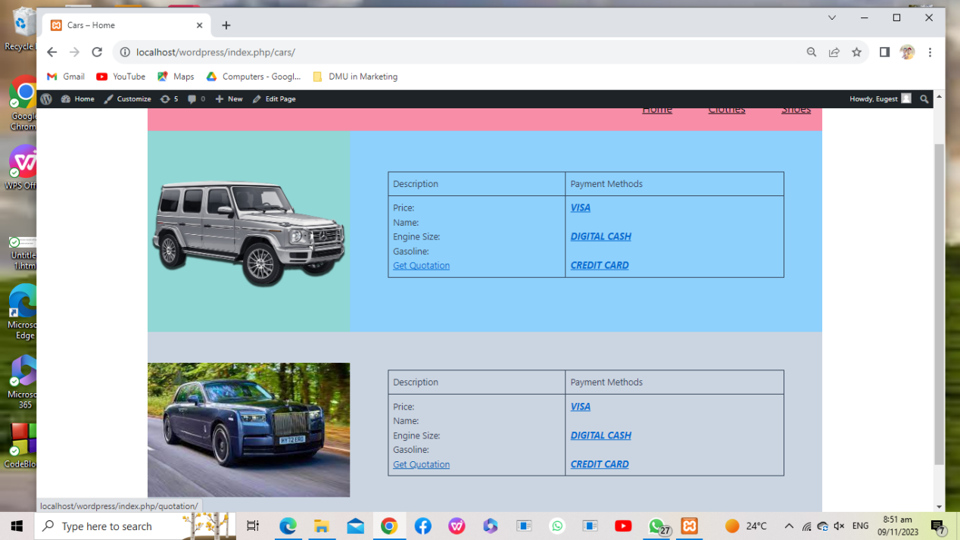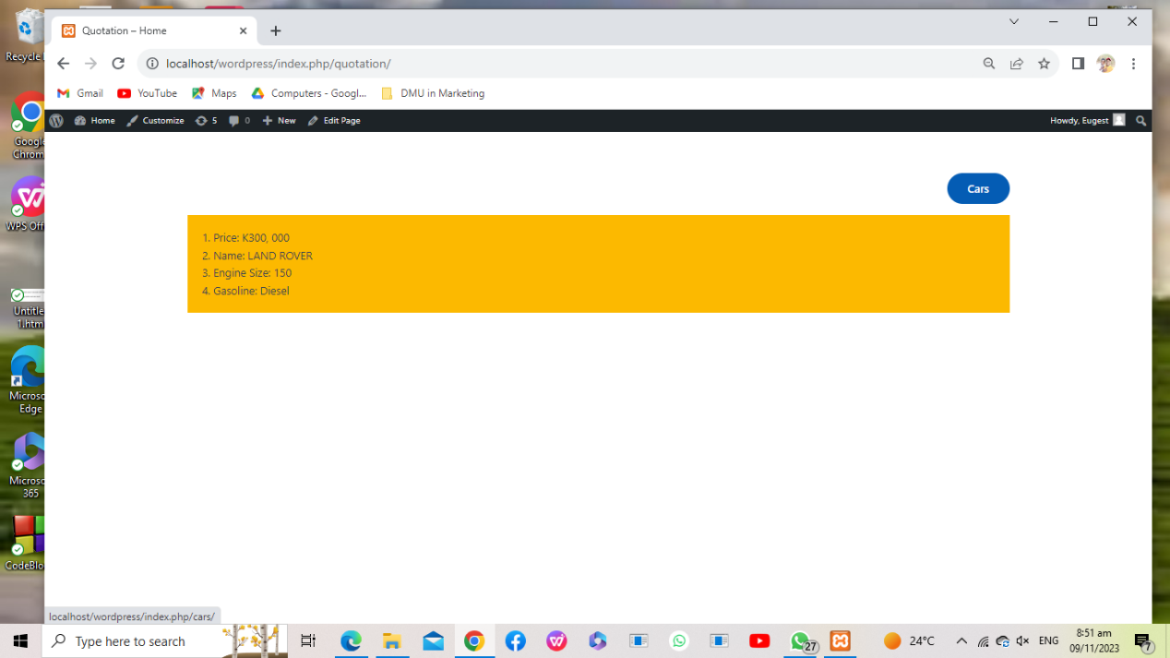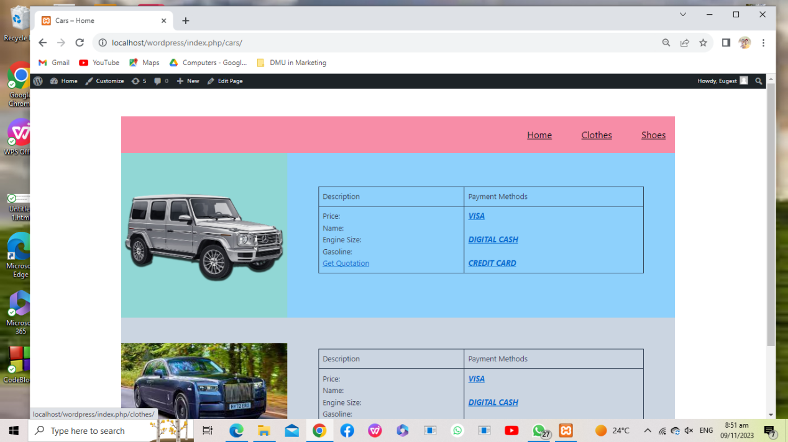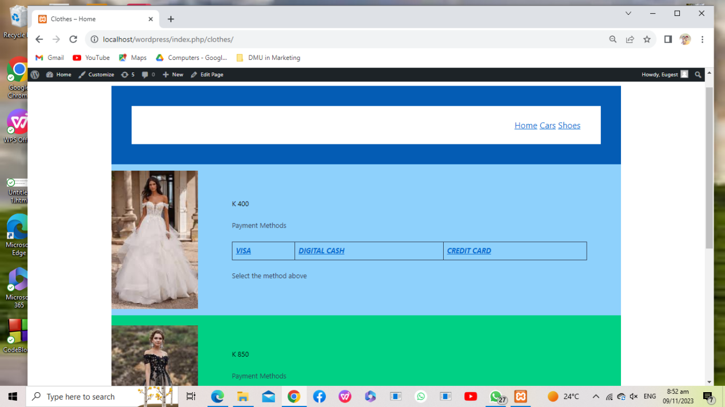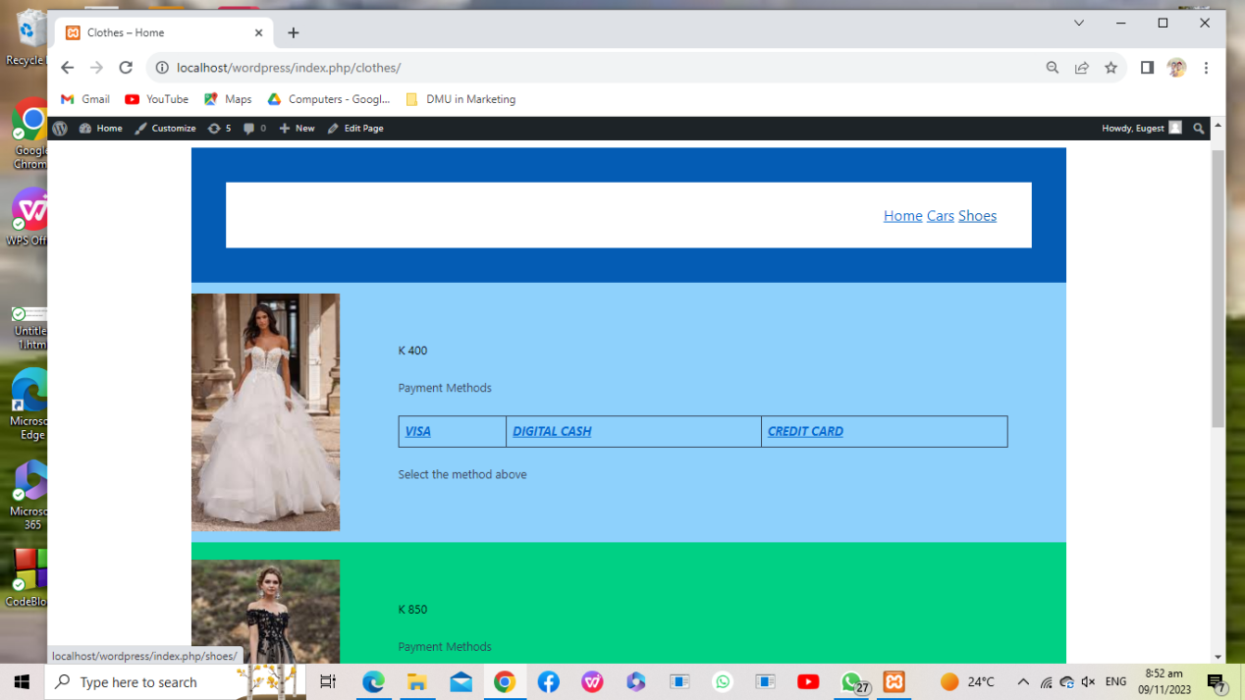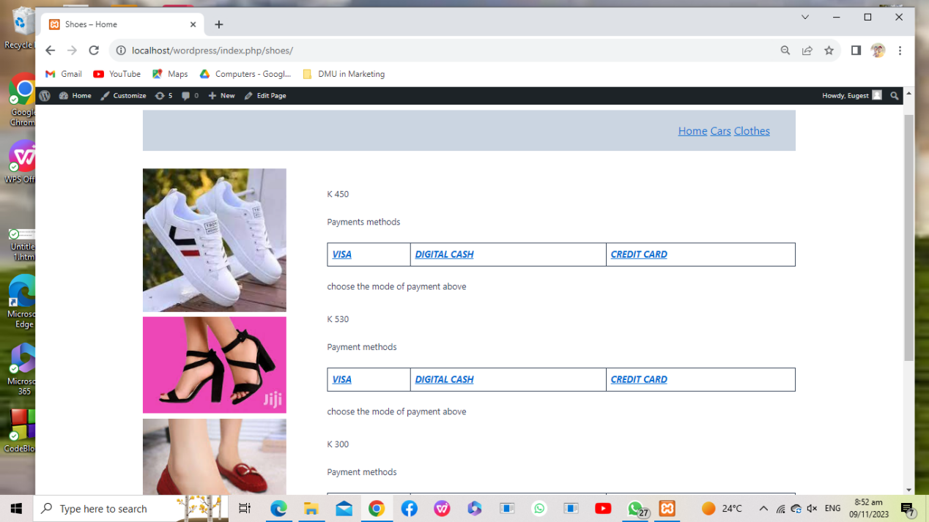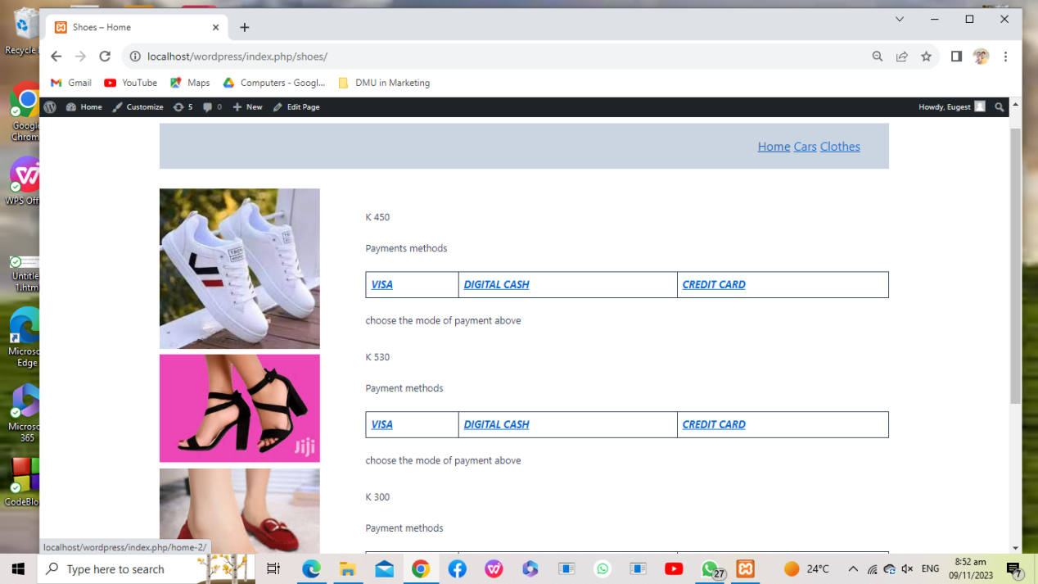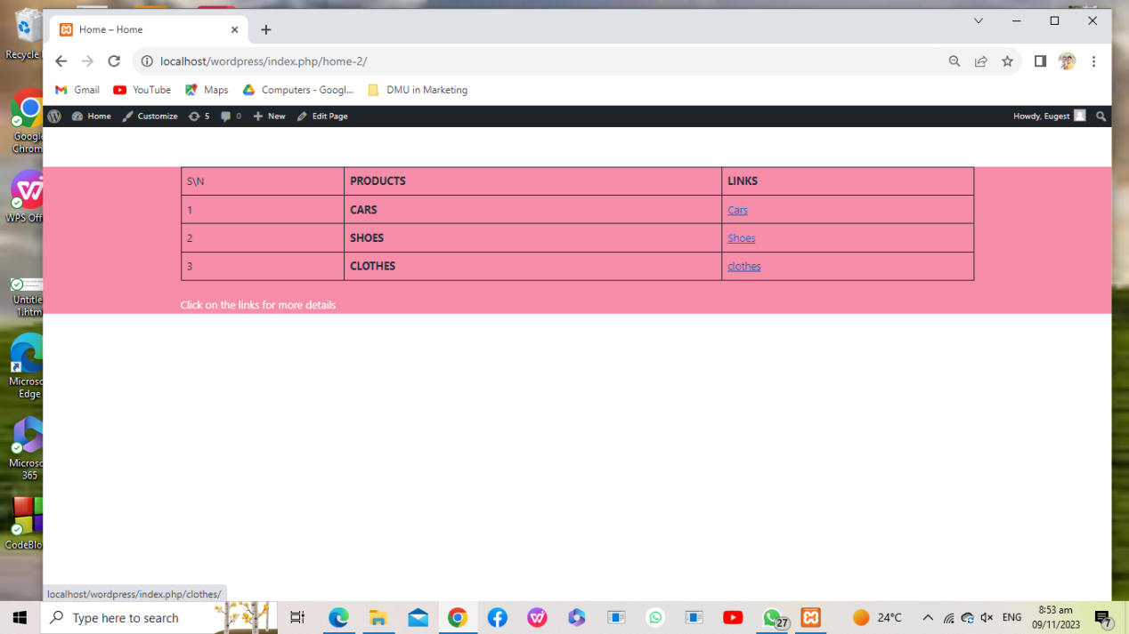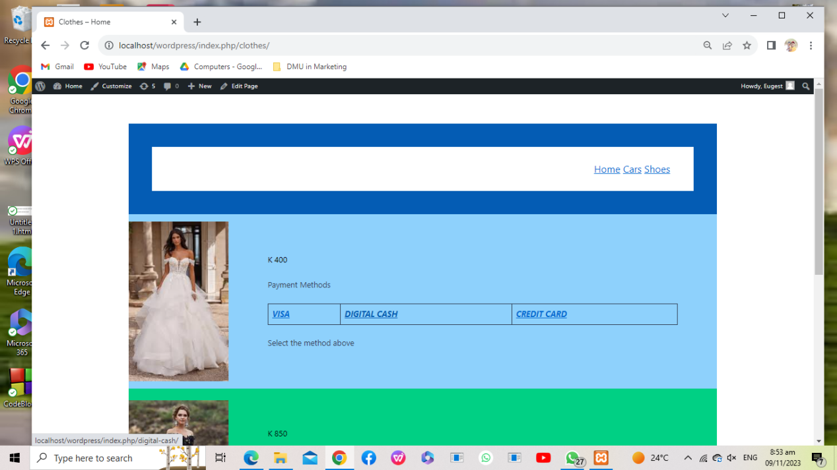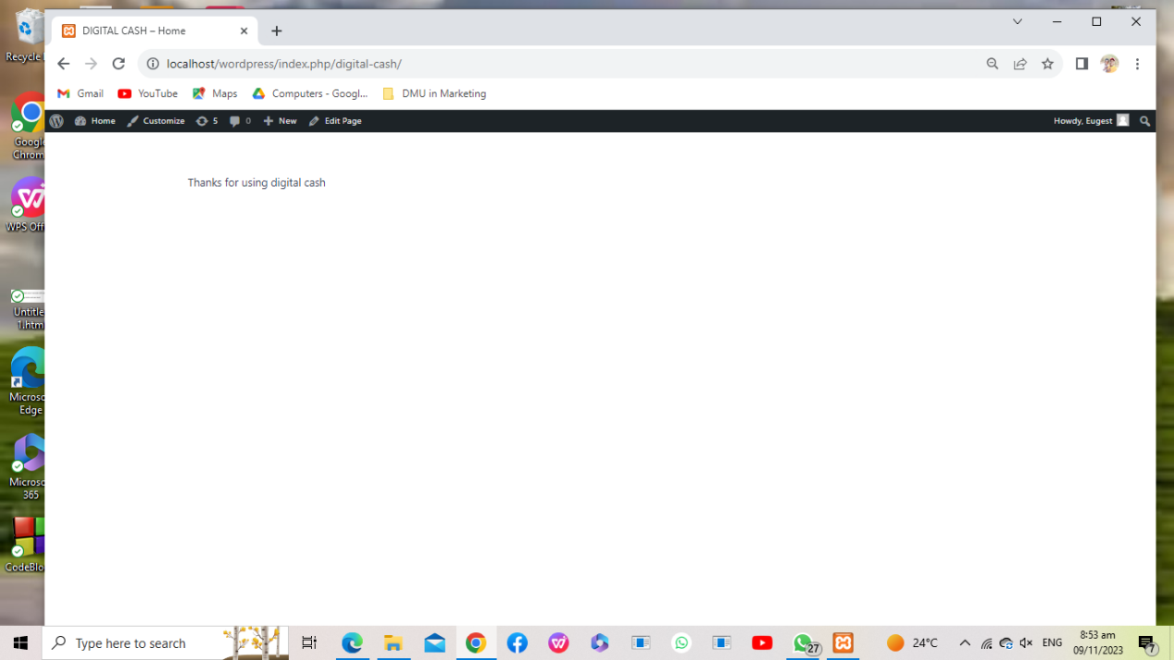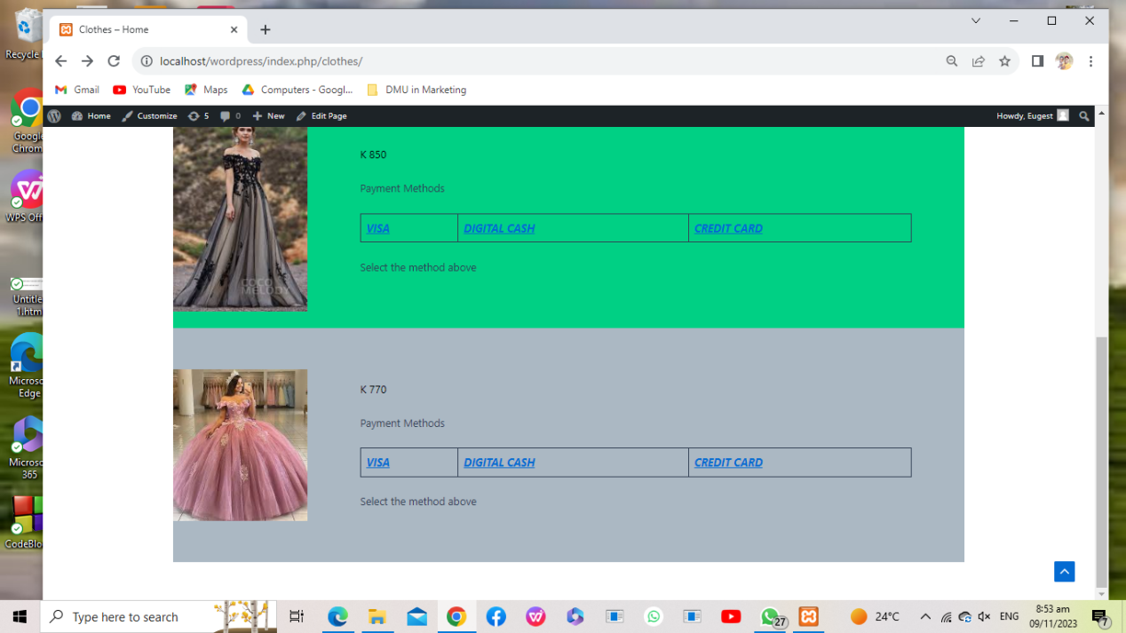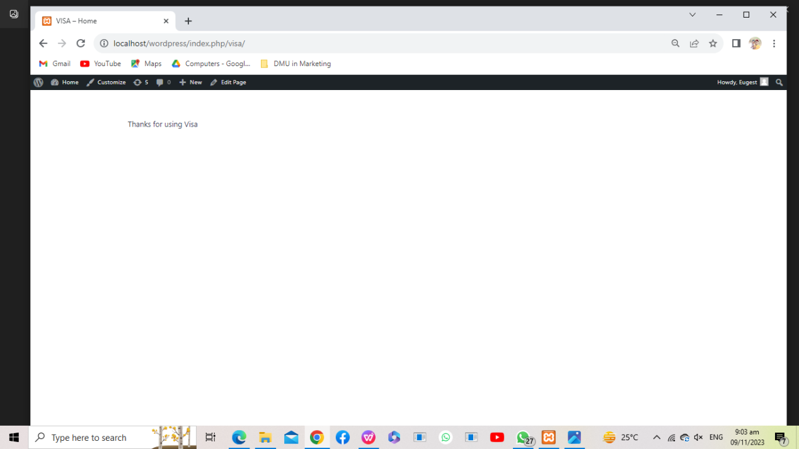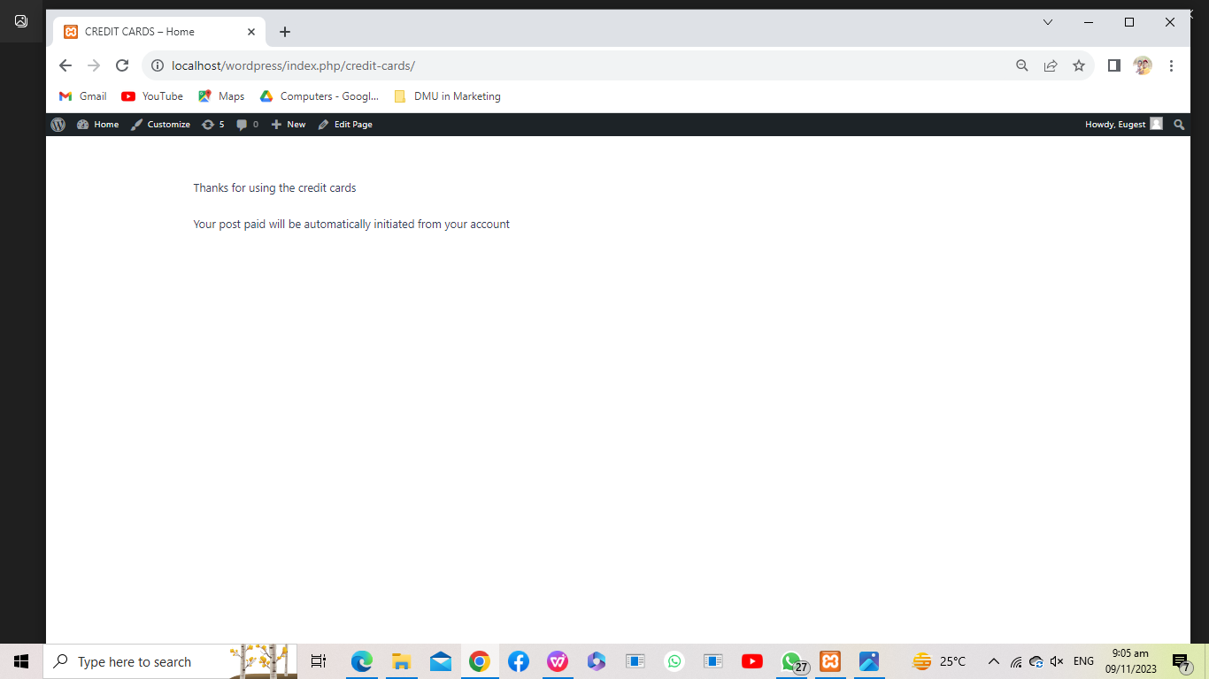

**The procedure which I took In developing this website**

First I installed xampp, its purpose was to create a database for the wordpress that I used to create a website.

Then I downloaded the wordpress file and install and set the adnim login name and password in the database.

I test if my wordpress had been installed and run in my database.

Thereafter I opened the wordpress on my via the crome and search; localhost/wordpress/login as a domain name for the website in the wordpress.

It does request me to enter the login name and password which I set in the database. After that I do login by pressing enter, if the login name and password are incorrect or one of them is incorrect then it will display wrong password or login name or email.

After login I started creating the new pages and link the segment such us parts of a paragraph and or tables and loop the nested links over each page.

The theme I installed which is Astra theme and used its features to design the website. This website can be expanded further based on what I experienced because the themes are many and different and each has its own features.

**CONCLUSION**

Lastly I would say this project has really helped me to get exposed into this model of developing the website for it was my first time and my task is to continue watching tutorials which have helped me to create this simple static website.

Its website that does not require codes but logic and testing the features of the theme you are using